**Product Customization Analytics - Manufacturing Sector**

GOKULNATH K & E24755

**Overview**

Product Customization Analytics in manufacturing involves analyzing customer-specific demands and tailoring production accordingly. For a data analyst, this includes tracking trends in customization requests, optimizing production workflows to handle variations efficiently, and using predictive models to forecast demand for customized products. It also involves evaluating the impact on cost, inventory, and production timelines to ensure profitability and customer satisfaction.

**Objective**

1. Identify customization trends based on customer preferences and market demand.
2. Optimize production processes to handle custom orders efficiently while minimizing costs.
3. Forecast demand for specific product customizations using predictive analytics.
4. Analyze the impact of customization on production timelines, inventory, and supply chain.
5. Improve customer satisfaction by ensuring timely delivery of customized products.
6. Enhance profitability by balancing customization flexibility with cost control strategies.

**Assigned Task(s)**

* Product Customization Analytics - Manufacturing Sector.

**Task Details**

* **Task 37 :** Product Customization Analytics in manufacturing involves using data to analyze customer preferences and tailor production accordingly. Data analysts focus on identifying trends, optimizing workflows, and balancing customization with cost efficiency.
* **Status:** Completed.
* **Details:**

1. Analyzed Dataset: Analyzed a detailed dataset such as customer_id, product_category,customization_type,quantity,price,order_date,customer_location, order_status, delivery_time_days, payment_method, and feedback_score.
2. Analytics:

* Calculated total sales (total_sales) by multiplying quantity and price.
* Grouped data by customization_type and calculated total sales for each type.

1. Visualizations:

* Bar Plot: Visualized total sales by customization_type.
* Line Plot: Showed total sales over time (order_date).
* Box Plot: Displayed distribution of total sales by feedback_score.
* Bar Plot: Compared total sales across different customer_location.
* Heatmap: Showed total sales by customization_type and delivery_time_days.
* Pie Chart: Visualized total sales distribution by payment_method

1. Predictive Modeling:

* Prepared data for linear regression using features like quantity, price, delivery_time_days, and feedback_score.
* Split the dataset into training and testing sets.
* Trained a LinearRegression model to predict total_sales.
* Evaluated the model using Mean Squared Error (MSE) and R-squared metrics.
* Visualized predictions versus actual sales using a scatter plot.

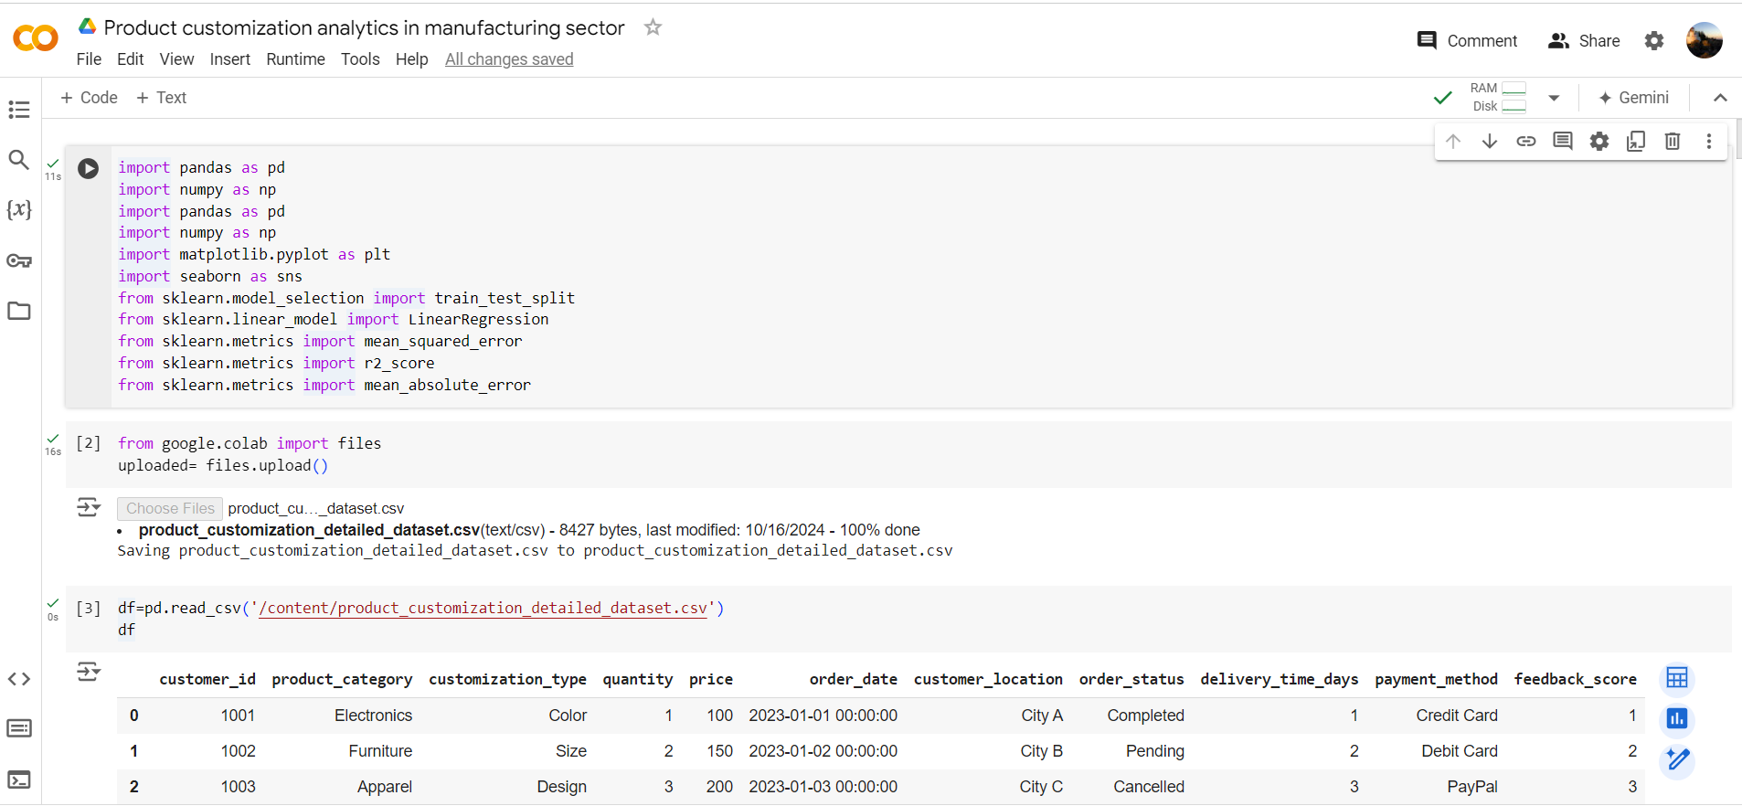

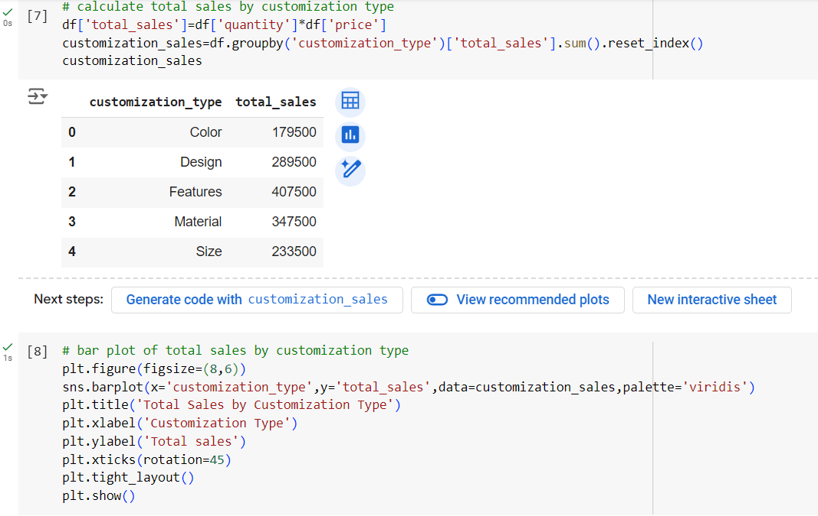

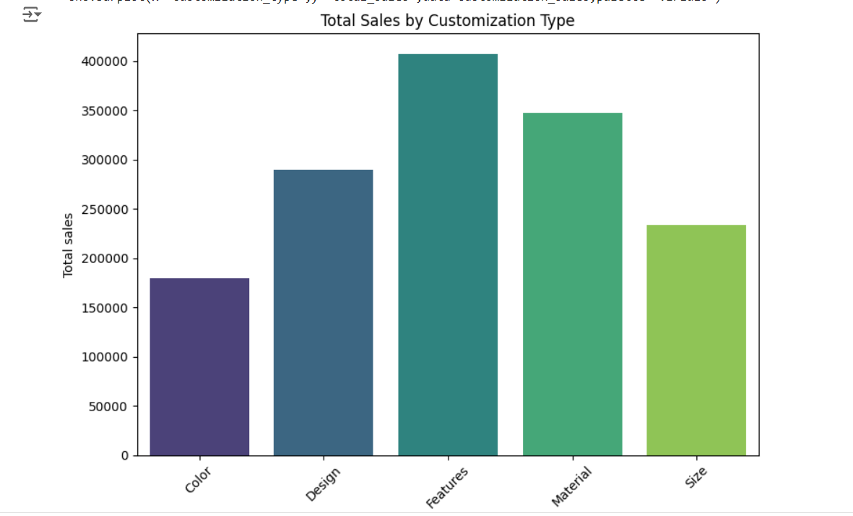

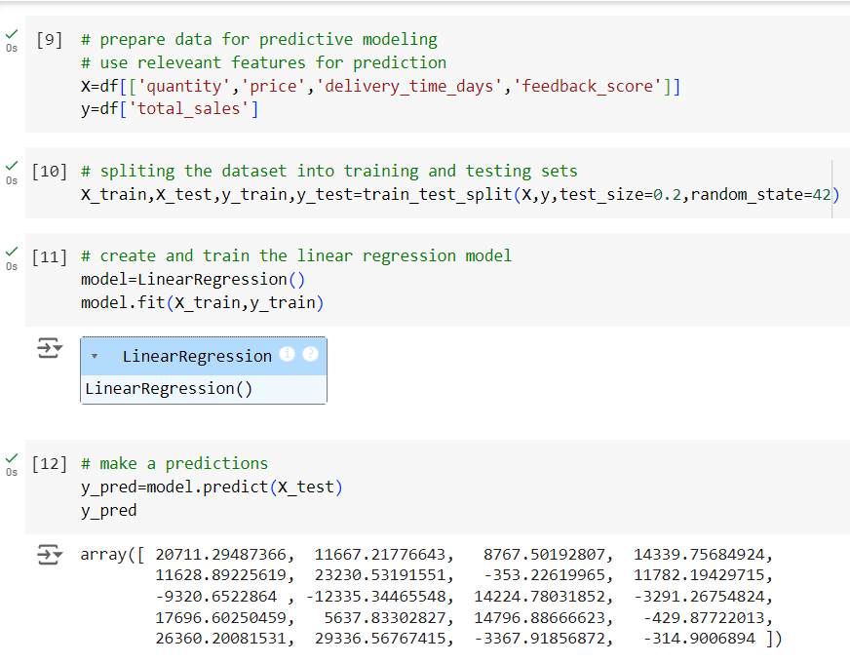

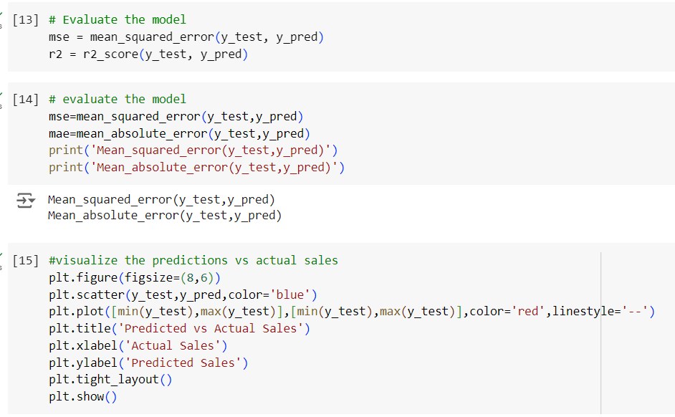

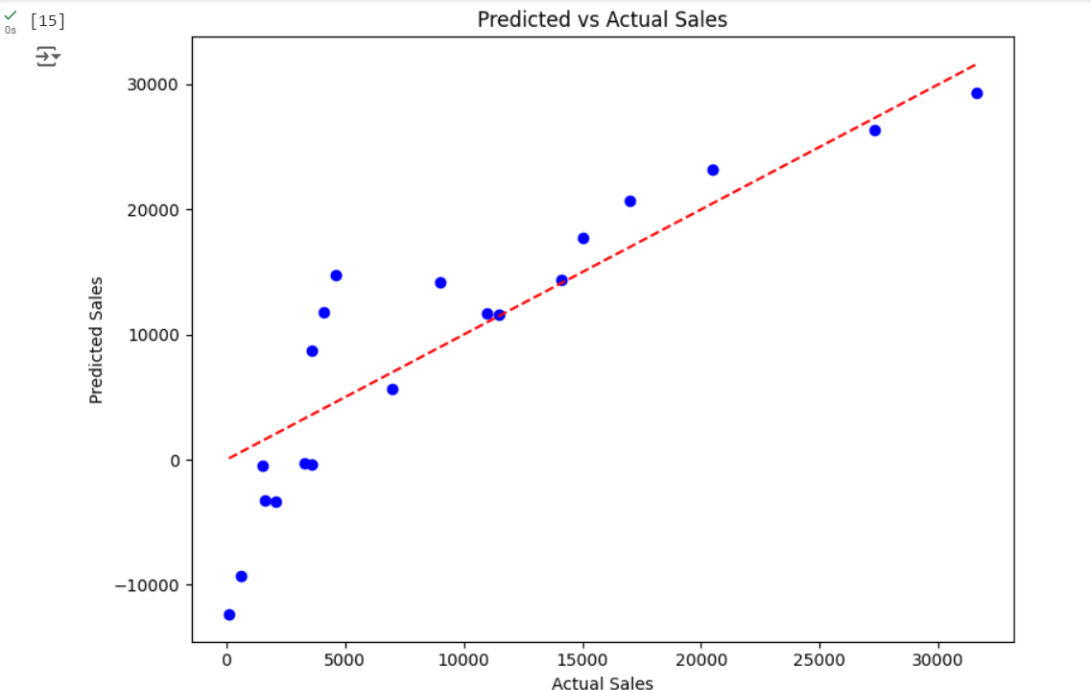

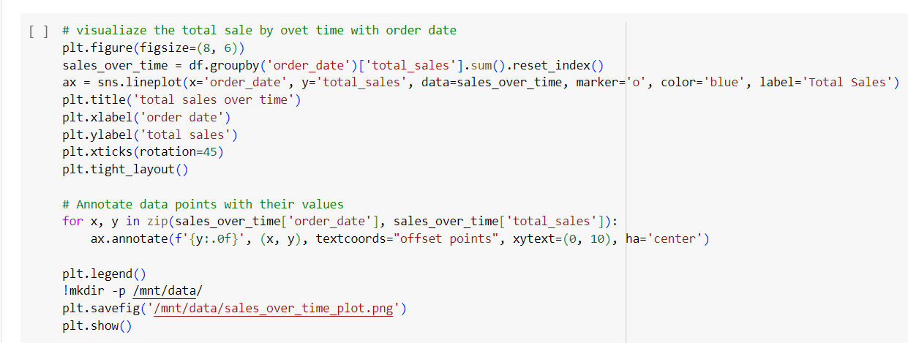

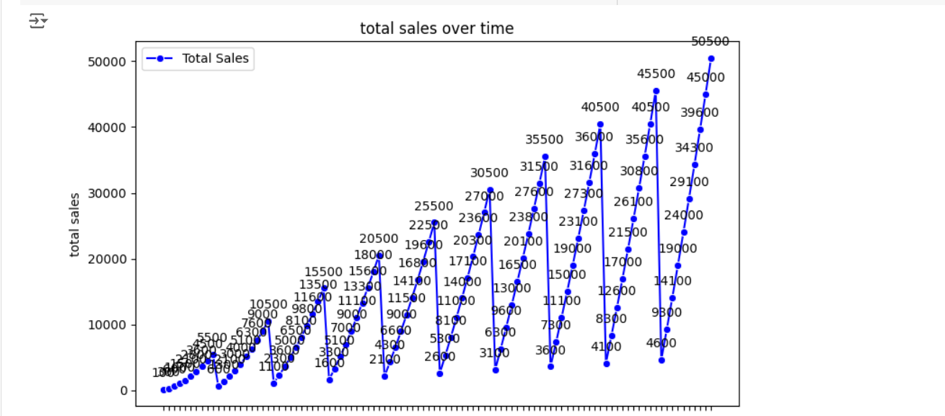

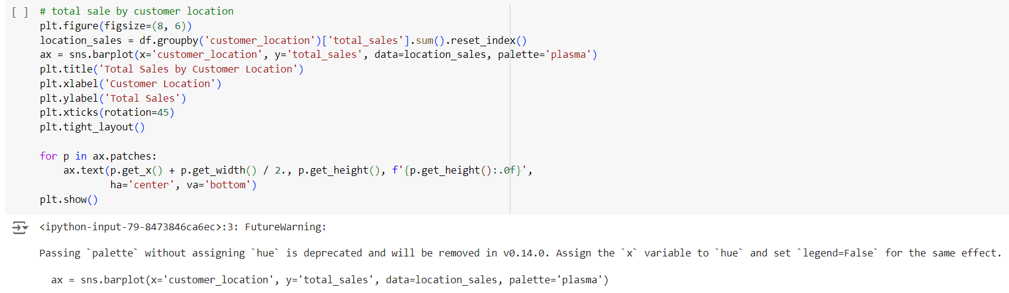

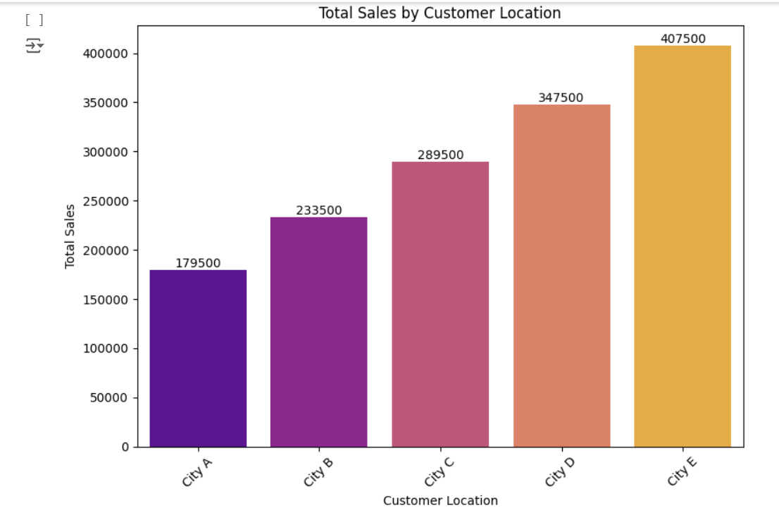

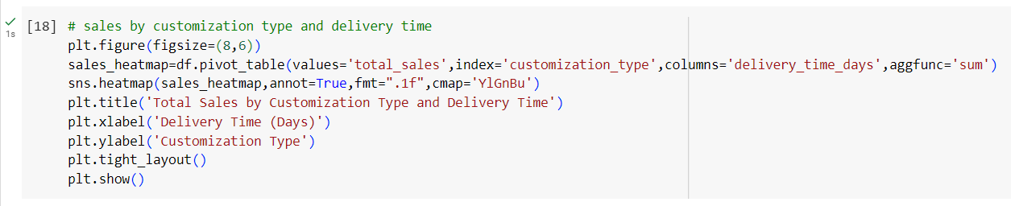

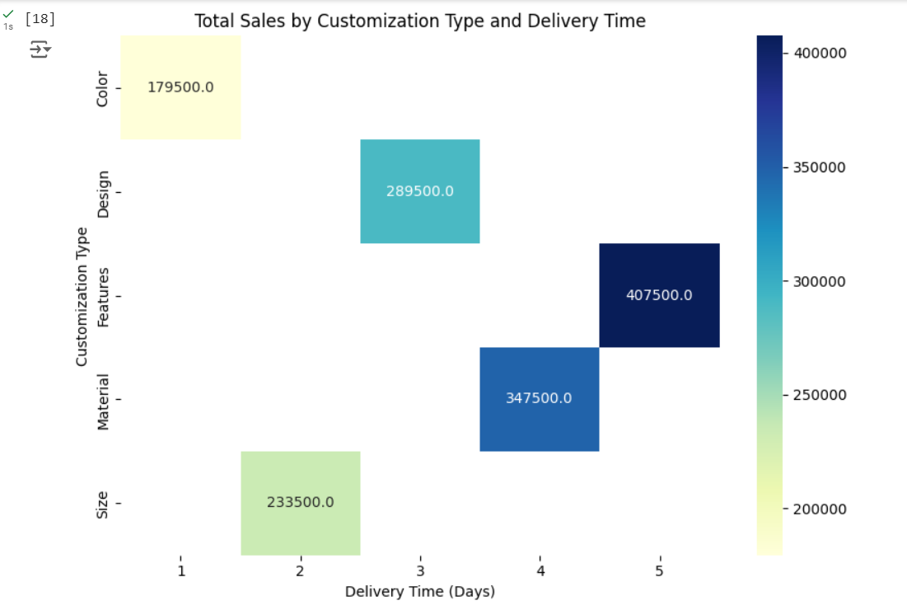

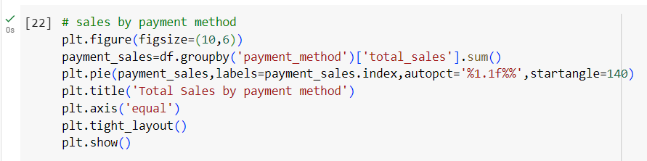

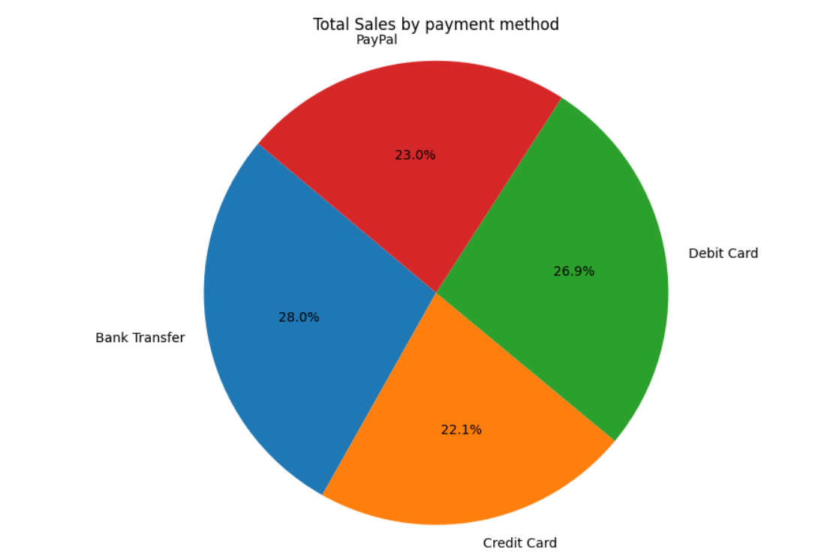

**Progress**

* **Accomplishments:**

1. Analyzed sales trends over time using line plots to identify peak sales periods.
2. Conducted feedback score analysis using box plots to understand sales distribution across customer ratings.
3. Visualized sales distribution by customer location using bar plots to uncover regional performance insights.
4. Created clear, data-driven visualizations to highlight key sales metrics for informed decision-making.

* **Metrics:**

1. Sum of sales across all periods.
2. Mean sales over time for trend analysis.
3. Average feedback rating per sale.
4. Percentage of total sales from each geographic location.
5. Change in sales volume over time.

**Challenges and Solutions**

* **Challenges Faced:**

1. Variability in feedback scores made it harder to derive uniform conclusions.
2. Difficulty in processing large volumes of data, leading to slow performance.
3. Incomplete or inconsistent entries that affected the accuracy of analysis.

* **Solutions Implemented:**

1. Created a weighted average system to normalize feedback and reduce variability.
2. Used efficient algorithms and tools like Python’s Pandas to handle large datasets without compromising performance.
3. Implemented systematic data cleaning processes to ensure consistency and completeness.

**Next Steps**

* **Upcoming Tasks:** Tackle upcoming tasks by optimizing data workflows, improving visual clarity in visualizations, and sharpening analytical methods for more precise outcomes.
* **Goals:** To meet goals, define specific targets, utilize data-driven insights, and regularly assess progress for effective strategy adjustments.

**Conclusion**

* **Summary:** Product customization analytics in the manufacturing sector enhances customer satisfaction by tailoring products to individual preferences. By leveraging data-driven insights, manufacturers can streamline processes, optimize resources, and improve overall efficiency. This approach not only drives competitive advantage but also fosters innovation in product development.
* **Acknowledgements:** Thank you all for your attention and engagement, I appreciate your interest in the Product Customization Analytics in the Manufacturing sector.